**Experiment-9**

**Aim:** Configure DHCP and SMTP in a small LAN

**Prerequisite:** Nil

**Outcome:** To impart knowledge of Application Layer Protocol

**Theory:**

* Dynamic Host Configuration Protocol (DHCP) is a network management protocol utilized to automate the assignment of IP addresses to devices within a network. Operating on the OSI model's Application Layer, it enables network administrators to centrally control and distribute IP addresses dynamically, eliminating the need for manual configuration on each device.
* When a device connects to a network, it initiates a DHCP discover message, requesting an IP address. This message is received by a DHCP server, which responds with a DHCP offer containing an available IP address and additional network configuration details like subnet mask, default gateway, and DNS server addresses. Upon receiving this offer, the device sends a DHCP request to confirm acceptance of the offered configuration. Subsequently, the DHCP server acknowledges the request, concluding the process and allowing the device to engage in network communication.
* Simple Mail Transfer Protocol (SMTP) is a standard communication protocol utilized for sending and receiving email messages over the internet. Operating at the OSI model's Application Layer, SMTP facilitates the transmission of emails between mail servers. It defines the text-based rules for communication between email clients or applications and email servers to dispatch messages.
* When a user sends an email, their email client interacts with their outgoing mail server (SMTP server) using SMTP. The client transmits the email containing essential details like the recipient's email address, subject, message body, and any attachments. The SMTP server then establishes a connection with the recipient's SMTP server, utilizing DNS (Domain Name System) to locate the recipient's mail exchange (MX) records to identify the appropriate server. Once the connection is established, the sender's SMTP server dispatches the email to the recipient's SMTP server.

**Procedure:**

1. Write Simple Client Server Program using Java/Python Programming Language.
2. Execute the program using appropriate compiler.
3. Verify the working of the program.

**Output:**

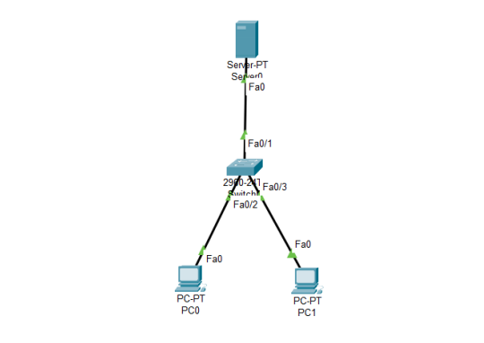

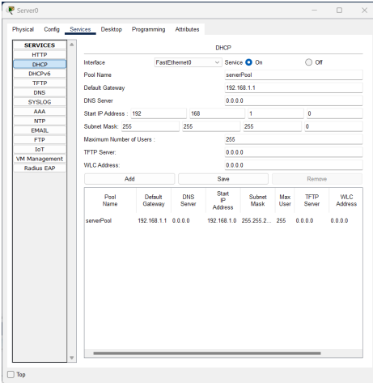

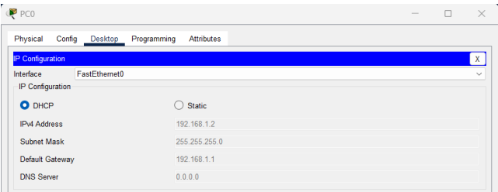

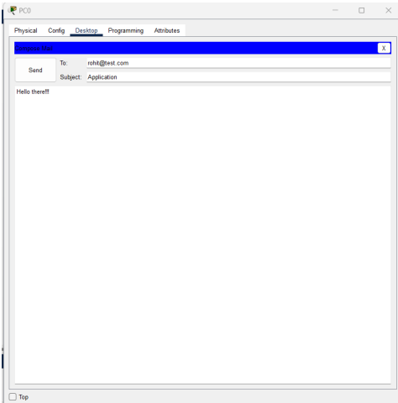

**Observation & Learning**

* In this practical test, we effectively set up DHCP (Dynamic Host Configuration Protocol) and SMTP (Simple Mail Transfer Protocol) within a small Local Area Network (LAN) using Cisco Packet Tracer. Through this, we observed the significant advantage of DHCP in simplifying the assignment of IP addresses to network devices. Devices connecting to the network automatically acquired essential network parameters such as IP address, subnet mask, default gateway, and DNS server information from the DHCP server. This automated process eliminated the necessity for manual configuration, reducing errors and saving time in network administration.
* Additionally, by configuring SMTP, we were able to successfully send and receive emails within the LAN. The SMTP protocol efficiently managed the transmission of email messages between the sender's and recipient's mail servers. This served as a clear illustration of SMTP's vital role in facilitating seamless communication through email services.

**Conclusion**

In summary, this practical demonstration effectively showcased the successful configuration of DHCP and SMTP protocols within a small LAN setup using Cisco Packet Tracer. It vividly illustrated how DHCP streamlined the allocation of IP addresses, thereby enhancing network efficiency and minimizing potential errors. Moreover, SMTP played a crucial role in enabling seamless email communication, highlighting its significant contribution to modern networking. This hands-on learning experience provided valuable insights into the real-world application of these protocols, emphasizing their importance in network management and communication systems. Overall, this exercise significantly contributed to our comprehension of DHCP and SMTP, both essential elements in contemporary networking infrastructure.

**Questions:**

**1. What are the different ports used by the DHCP and SMTP?**

**Ans:**

* DHCP primarily operates through two ports: UDP (User Datagram Protocol) port 67 and UDP port 68. Upon a device's network connection, it sends a DHCP discovery request via UDP port 68. In response, the DHCP server transmits a DHCP offer message to the device's UDP port 67. Once the offer is accepted, the DHCP server and the device use these ports for communication to complete the configuration process. This process involves furnishing the device with vital network details such as IP address, subnet mask, gateway, and DNS servers.
* In contrast, SMTP largely employs TCP (Transmission Control Protocol) port 25 for communication. Responsible for transmitting email messages over a network, SMTP initiates an email transfer when an email is sent. The sending mail server establishes a connection with the receiving mail server on port 25 to commence the email transmission process. Despite SMTP supporting encrypted connections through SSL/TLS on port 465 or STARTTLS on port 587, port 25 remains the default and most widely used port for SMTP communication.

**2. What are the benefits of using DHCP services?**

**Ans:** DHCP (Dynamic Host Configuration Protocol) presents multiple advantages in network management:

1. Automatic IP Address Allocation: DHCP automates the assignment of IP addresses to devices within a network. This eliminates the necessity for manual configuration, reducing the potential for human errors and ensuring each device receives a unique, valid IP address.
2. Efficient Resource Utilization: DHCP optimizes the utilization of available IP addresses by dynamically allocating and reclaiming addresses as devices join or leave the network. It allocates addresses only when necessary, thereby preventing address exhaustion.
3. Centralized Management: DHCP facilitates centralized control and configuration of IP addresses. Network administrators can conveniently set parameters like lease durations, subnet masks, gateways, and DNS servers in one location, streamlining the management of numerous devices.
4. Reduced Configuration Errors: Manual IP configuration may lead to errors such as duplicate IP addresses or incorrect subnet configurations. DHCP mitigates these errors by automating the process.
5. Simplified Device Deployment: DHCP simplifies the setup process when integrating new devices into a network. Devices can be plugged in and connected to the network without the need for manual configuration, saving time and effort in deployment.

**3. What is the role of Active Directory in the DHCP context?**

**Ans:**

* Active Directory (AD) is a Microsoft-developed directory service that holds significant importance concerning the Dynamic Host Configuration Protocol (DHCP) within Windows-based network environments.
* A pivotal role of Active Directory in DHCP is managing and registering DNS (Domain Name System) records. When a client device acquires an IP address from a DHCP server, it necessitates registering its associated DNS records. Active Directory simplifies this procedure by providing a centralized database storing DNS records for all network devices, including those dynamically assigned by DHCP.
* Integration of Active Directory with DHCP enables secure and dynamic updates of DNS records. As a result, when a DHCP client obtains a new IP address, it can autonomously update its DNS record within the Active Directory DNS zone. This dynamic update mechanism ensures that DNS records accurately reflect the current state of the network.
* Moreover, Active Directory facilitates the use of DHCP user classes and vendor classes. These additional parameters allow customization of DHCP options based on the type or vendor of the client device. For instance, distinct configurations can be applied to devices from various manufacturers or different types of devices, such as workstations, printers, or phones.